Query 1:

Command:

SELECT \*

FROM customers;

Screenshot:

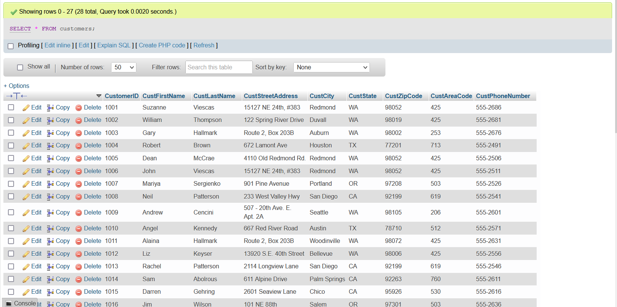

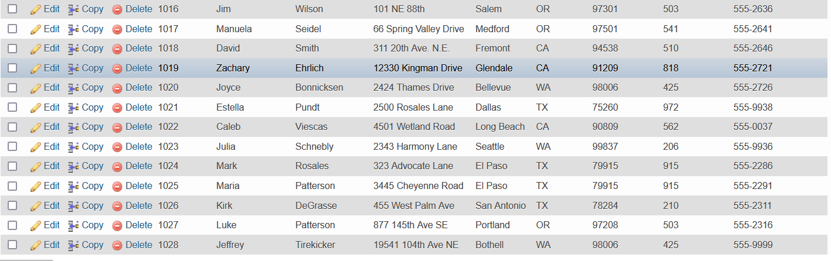

(please turn over to see next query)

Query 2:

Command:

SELECT CustFirstName as firstname ,CustLastName as lastname,concat('+',CustAreaCode,' ',CustPhoneNumber) as phone

FROM customers;

(simpliefied the names to firstname, lastname and phone for ease of view in query)

(also added + and a space between areacode and phone number to make it more readable)

Screenshot:

